Oliver Collins-Cope

2102775@rutc.ac.uk

Learning Aim B & C

Carry out project initiation for an IT project and carry out the planning, execution, monitoring, and controlling an IT project, using an appropriate methodology

Unit 9 assignment 2

Assignment 2

Contents

# Introduction

# IT Problem and solution

## Problem

The problem for this project is using the correct software to accurately develop a successful website. There are many options available to develop websites, such as notepad++, visual studio code, visual studio community, and Dreamweaver, and among these many options we will have to choose one that works effectively for our project. Below is a display of the website and how it should work when all it comes together, taken from the initial design of the project.

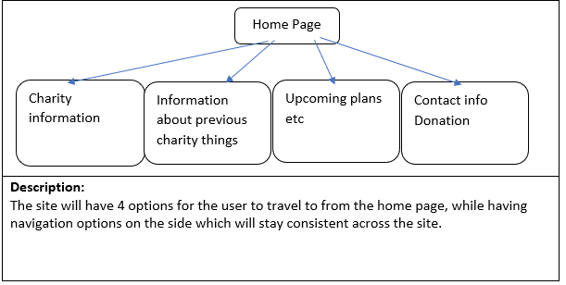

This is the initial sitemap which displays the different pages that will be available for the project.

## Solution 1

The first solution is to make the website using visual studio code. Visual studio code is a lightweight code editor with many powerful tools, such as having options for plugins and add-on onto the software in order to enhance it (VS Code, 2023). There are advantages to using visual studio code and these are detailed below describing the strengths:

* Support for multiple programming languages. This will enable me to do javascript and CSS inside of VS Code as well.
* Intelli-Sense, this is a Microsoft exclusive feature that aims to help developers by trying to autocomplete the code that the developer is typing.
* Cross platform support, this is the fact that visual studio code can be used by all devices, such as Mac, Linux, and Windows, making it somewhat unique as a code editor.
* Extensions and plugins, this is where VS Code offers options for plugins and extensions to improve the base application for visual studio code and expand on it. (Pedamkar, 2023)

On the other hand, some of the weaknesses and disadvantages of VS Code include:

* It is not as extensive and feature rich as other IDEs, such as Visual Studio Community
* It does not work well for specific kinds of development such as mobile applications or game development
* It can encounter performance issues with largescale projects
* Some users might find the UI less intuitive compared to other options available (Maurya, 2023)

## Alternative solution 1

Another option that might be used is Notepad++. This is similar to visual studio code as it is another lightweight editor and works well for projects like web development. Some of the advantages can be found detailed below:

* Notepad++ allows users to edit any of their scripts without having to access any heavy duty editors or software that might require a long loading time for minimal changes
* There is different syntax highlighting for all scripting languages, such as html and JavaScript
* It is completely free and there is a lot of support available online for it
* It is simple and intuitive to use the software for beginners (TrustRadius, 2023)

Some of the weaknesses and disadvantages of the software include:

* It has many bugs, such as when updating the software and this can lead to issues in development
* Opening files over a certain size can cause issues with the software and that is not ideal for our website as we do not want to have the website crash during development
* It lacks support for code auto completion and formatting, putting it behind when compared to newer code editors
* It does not have as many features compared to newer code editors (TrustRadius, 2023)

## Alternative solution 2

Another alternative solution for this project is to use Dreamweaver. Dreamweaver is Adobes IDE for website development and is highly optimised for this, offering options such as making tables through drop down boxes and is an efficient tool for developing a website for this project. Some of